**PERSONALIZED STUDY PLANNER BOT**

**A PROJECT REPORT**

***Submitted by***

**SNEKHA R (220701282)**

***in partial fulfillment for the course***

**OAI1903 - INTRODUCTION TO ROBOTIC PROCESS AUTOMATION**

***for the degree of***

**BACHELOR OF ENGINEERING**

***in***

**COMPUTER SCIENCE AND ENGINEERING**

**RAJALAKSHMI ENGINEERING COLLEGE**

**RAJALAKSHMI NAGAR**

**THANDALAM**

**CHENNAI – 602 105**



**NOVEMBER 2024**

**RAJALAKSHMI ENGINEERING COLLEGE**

**CHENNAI – 602105**

**BONAFIDE CERTIFICATE**

Certified that this project report **“PERSONALIZED STUDY PLANNER BOT”** is the bonafide work of **“SNEKHA R (220701282)”** who carried out the project work for the subject OAI1903-Introduction to Robotic Process Automation under my supervision.

**Mrs. U. Farjana, M.Tech.**

**SUPERVISOR**

Assistant Professor

Department of Computer Science and Engineering

Rajalakshmi Engineering College

Rajalakshmi Nagar

Thandalam

Chennai – 602105

Submitted to Project and Viva Voce Examination for the subject OAI1903-Introduction to Robotic Process Automation held on __________.

**INTERNAL EXAMINER EXTERNAL EXAMINER**

**ACKNOWLEDGEMENT**

Initially we thank the Almighty for being with us through every walk of our life and showering his blessings through the endeavour to put forth this report. Our sincere thanks to our Chairman **Thiru. S.Meganathan, B.E., F.I.E.,** our Vice Chairman **Mr. M.Abhay Shankar, B.E., M.S.,** and our respected Chairperson **Dr. (Mrs.) Thangam Meganathan, M.A., M.Phil., Ph.D.,** for providing us with the requisite infrastructure and sincere endeavouring in educating us in their premier institution.

Our sincere thanks to **Dr. S.N.Murugesan, M.E., Ph.D.,** our beloved Principal for his kind support and facilities provided to complete our work in time. We express our sincere thanks to **Dr. P.Kumar, M.E., Ph.D.,** Professor and Head of the Department of Computer Science and Engineering for his guidance and encouragement throughout the project work. We convey our sincere and deepest gratitude to our internal guide, **Ms. U.Farjana, M.Tech.,** Assistant Professor for their valuable guidance throughout the course of the project. We are very glad to thank our Project Coordinators, **Dr. N.Durai Murugan, M.E., Ph.D.,** Associate Professor, and **Mr. B.Bhuvaneswaran, M.E.,** Assistant Professor (SG), Department of Computer Science and Engineering for their useful tips during our review to build our project.

**SNEKHA R (220701282)**

**ABSTRACT**

The **Personalized Study Planner Bot** is an innovative Robotic Process Automation (RPA) solution developed using UiPath to help students efficiently manage their study schedules. This bot automates the creation and maintenance of personalized study plans, leveraging input data such as subjects, deadlines, and preferred study hours collected from Excel sheets. Using advanced scheduling algorithms, it dynamically allocates study hours, prioritizing tasks with earlier deadlines or higher importance to ensure students meet their academic goals on time. A key feature of the bot is its ability to track daily progress. By monitoring completed study hours, recalculating remaining hours, and adjusting schedules, the bot ensures that students remain on track even if circumstances change. Automated email notifications remind students of upcoming study sessions, fostering consistency and accountability. Additionally, the bot generates detailed progress reports, offering insights into study hours completed, tasks pending, and overall performance. These updates allow students to make informed decisions about their study routines. The bot’s user-friendly and adaptive design eliminates the manual effort of planning and tracking study schedules, making it easier for students to focus on their learning. By automating reminders, progress tracking, and schedule adjustments, the **Personalized Study Planner Bot** provides a smart and reliable approach to time management. This innovative tool empowers students to maintain productivity, achieve academic success, and effectively balance their study workload, making it an indispensable resource for modern learners.

**TABLE OF CONTENTS**

**CHAPTER NO. TITLE PAGE NO.**

**ABSTRACT iii**

**LIST OF TABLE iv**

**LIST OF FIGURES v**

**LIST OF ABBREVIATIONS vi**

**1. INTRODUCTION 1**

1.1 GENERAL 1

1.2 OBJECTIVE 1

1.3 EXISTING SYSTEM 2

1.4 PROPOSED SYSTEM 2

**2. LITERATURE REVIEW 3**

2.1 GENERAL 3

**3. SYSTEM DESIGN 5**

3.1 GENERAL 5

3.1.1 SYSTEM FLOW DIAGRAM 5

3.1.2 ARCHITECTURE DIAGRAM 6

3.1.3 SEQUENCE DIAGRAM 7

**4. PROJECT DESCRIPTION 8**

4.1 METHODOLOGIE 8

4.1.1 MODULES 8

**5. CONCLUSIONS 13**

6.1 GENERAL 13

**REFERENCES 14**

**APPENDICES 15**

**LIST OF FIGURES**

|  |  |  |
| --- | --- | --- |
| **Figure No** | **Figure Name** | **Page No.** |
| 3.1 | System Flow Diagram | **4** |
| 3.2 | Architecture Diagram | **5** |
| 3.3 | Sequence Diagram | **6** |
| 5.1 | Email output for high priority subjects | 15 |
| 5.2 | Email output for updated study plan | 15 |
| 5.3 | Excel input | 16 |
| 5.4 | Excel output for study plan | 16 |
| 5.5 | Excel output for updated study plan based on completed hours | 16 |
| 5.6 | Workflow screenshot 1 | 17 |
| 5.7 | Workflow screenshot 2 | 17 |
| 5.8 | Workflow screenshot 3 | 18 |
| 5.9 | Workflow screenshot 4 | 18 |

**LIST OF ABBREVIATIONS**

|  |  |
| --- | --- |
| **ABBREVIATION** | **ACCRONYM** |
| RPA | Robotic Process Automation |
| SMTP | Simple Mail Transfer Protocol |
| AI | Artificial Intelligence |
| DT | Data Table |

**CHAPTER 1**

**INTRODUCTION**

* 1. **GENERAL**

Managing academic schedules effectively is a critical challenge for students striving to meet their educational goals. With multiple subjects, assignments, and exams requiring attention, students often face difficulty prioritizing tasks and allocating time efficiently. A personalized approach to study planning that adapts dynamically to changes in deadlines and progress is essential for achieving academic success. The Personalized Study Planner Bot, powered by Robotic Process Automation (RPA) and developed using UiPath, offers an innovative solution to these challenges. By automating the creation, tracking, and adjustment of study plans, the bot ensures efficient time management while reducing the manual effort involved in scheduling**.**

In General, The Personalized Study Planner Bot is designed to provide students with an intelligent, automated way to manage their study routines. It focuses on creating dynamic and adaptive study schedules tailored to individual needs, such as deadlines, preferred study hours, and priorities. By leveraging RPA, the bot automates repetitive tasks like tracking progress, sending reminders, and updating schedules. This not only saves time but also enhances productivity and focus.

* 1. **OBJECTIVE**

The primary objective of the Personalized Study Planner Bot is to empower students to meet their academic goals by providing a user-friendly, automated tool for study planning. Key goals include:

* Automating the creation of personalized study schedules based on individual preferences.
* Prioritizing tasks to ensure critical deadlines are met.
* Tracking daily progress and recalculating schedules dynamically.
* Providing timely notifications and reminders to maintain consistency.

**1.3 EXISTING SYSTEM**

In the current manual system, students often rely on static schedules or personal judgment to plan their studies. Challenges include:

* Difficulty in prioritizing tasks based on deadlines and importance.
* Inability to adapt to changing circumstances, such as missed sessions or revised deadlines.
* Time-intensive manual tracking of progress and adjustments to study plans.
* Lack of automated notifications or insights into performance.

These limitations hinder students' ability to stay organized and achieve optimal results.

* 1. **PROPOSED SYSTEM**

The Personalized Study Planner Bot addresses the shortcomings of the existing system by introducing a robust, automated approach to study planning. The proposed system:

* Collects input data such as subject details, deadlines, and preferred hours via Excel sheets or forms.
* Uses intelligent scheduling algorithms to allocate study hours dynamically, prioritizing urgent tasks.
* Tracks completed hours daily, recalculates remaining hours, and adjusts schedules accordingly.
* Sends automated email reminders for upcoming study sessions.
* Generates comprehensive progress reports with actionable insights.

This adaptive and intelligent system eliminates manual effort, ensures flexibility, and enhances students’ ability to meet their academic goals effectively.

**CHAPTER 2**

**LITERATURE REVIEW**

**2.1 GENERAL**

[1] Automating Study Scheduling Using Robotic Process Automation (RPA):

RPA has been extensively used in automating repetitive and rule-based tasks across industries. However, its application in educational domains remains limited. Studies suggest that automation can efficiently handle tasks like scheduling and progress tracking. Research highlights the potential of RPA in creating dynamic and adaptive solutions for personalized education management. This project builds on these findings by using UiPath to automate study scheduling and tracking, addressing the lack of dynamic rescheduling capabilities in existing tools.

[2] Dynamic Task Prioritization in Automated Systems:

Previous research on task prioritization emphasizes the need for adaptive systems that adjust priorities based on deadlines and task urgency. Algorithms used in these studies effectively allocate resources and time dynamically. The Personalized Study Planner Bot incorporates such scheduling algorithms to ensure that students’ study plans adapt to real-time inputs like completed hours and changing deadlines. This aligns with findings from task automation studies, which stress the importance of real-time updates for optimal outcomes.

[3] Email Automation for Personalized Notifications:

Studies on automated email systems reveal that timely reminders and notifications significantly improve task adherence. Email automation tools like SMTP are widely used in industries for reminders, progress reports, and updates. This bot integrates email automation to remind students about scheduled sessions and deadlines, leveraging findings that consistent communication can enhance user engagement and accountability.

[4] Progress Tracking and Analytics in Educational Tools:

Existing research on educational analytics focuses on tracking user performance and providing actionable insights. Studies have highlighted the role of analytics in improving learning outcomes by identifying patterns in user behavior. The Personalized Study Planner Bot integrates these findings by maintaining detailed logs of study hours and generating progress reports, helping students evaluate their performance and make data-driven adjustments to their schedules.

[5] Integrating RPA with User-Friendly Interfaces:

RPA systems often face criticism for their complexity and steep learning curves for non-technical users. Studies advocate for integrating RPA tools with user-friendly platforms like Excel and simple input forms. This project addresses these challenges by allowing students to input their data through familiar tools like Excel, ensuring accessibility and ease of use, in line with research advocating seamless user interaction in automation solutions.

**CHAPTER 3**

**SYSTEM DESIGN**

**3.1.1. SYSTEM FLOW DIAGRAM**

The System Flow Diagram represents the overall workflow of the Personalized Study Planner Bot:

1. Input Phase: User enters details (subject, deadlines, preferred hours) via an Excel sheet or form.
2. Processing Phase: The bot processes input data to calculate priorities and allocate study hours dynamically.
3. Execution Phase: Scheduled study plans are updated daily, and reminders are sent via
4. Output Phase: Updated schedules are provided to the user 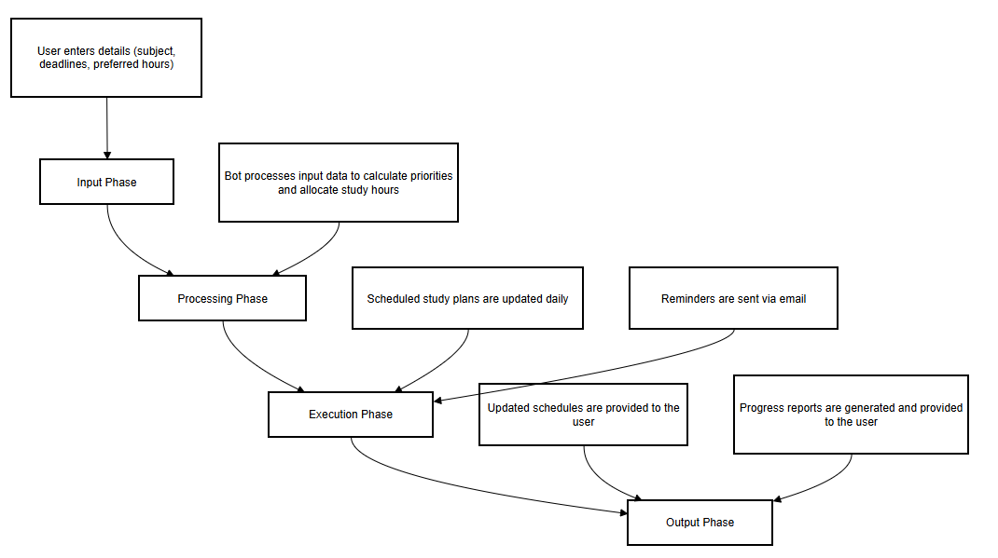

Fig 3.1 System Flow diagram

**3.1.2 ARCHITECTURE DIAGRAM**

The Architecture Diagram illustrates the structural framework of the bot:

1. User Interface: Excel or form-based input mechanism for user details.
2. Processing Layer: UiPath workflows for data validation, scheduling, and recalculation of hours.
3. Notification Module: Email integration for reminders using SMTP/Outlook activities.
4. Reporting Module: Progress tracking and report generation using Excel activities.

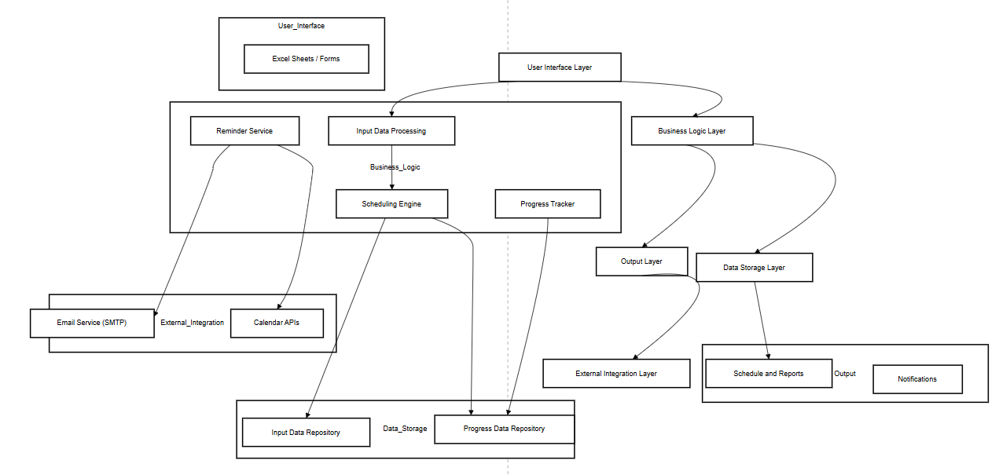

Fig 3.2 Architecture diagram

**3.1.3 SEQUENCE DIAGRAM**

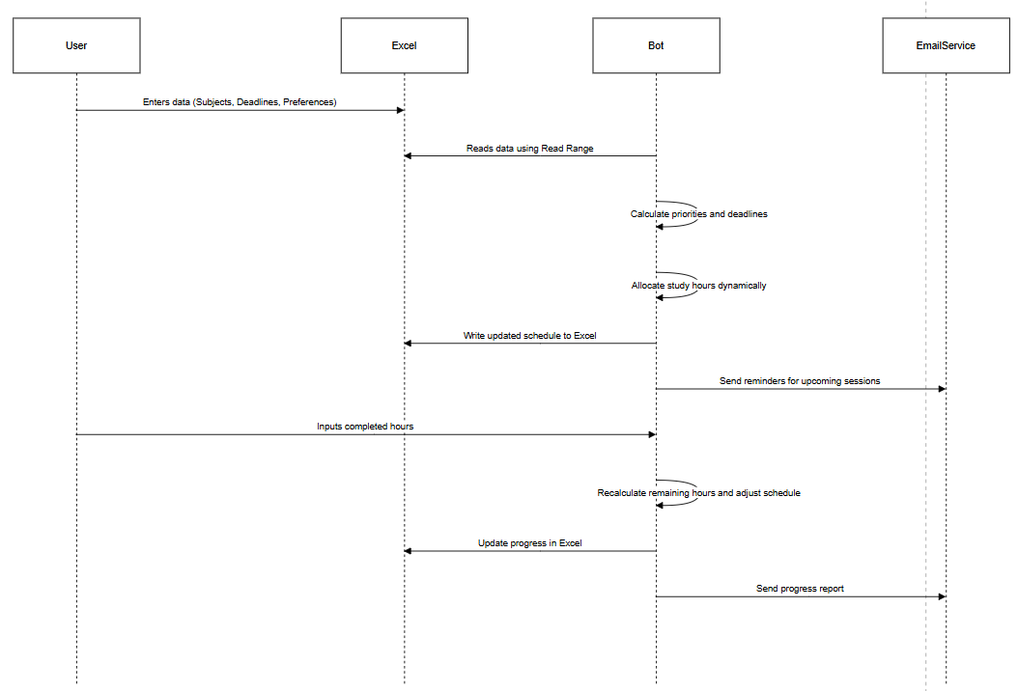

Fig 3.3 Sequence diagram

**CHAPTER 4**

**PROJECT DESCRIPTION**

The Personalized Study Planner Bot is a comprehensive automation solution developed using UiPath to assist students in planning, tracking, and adjusting their study schedules dynamically. The bot leverages RPA (Robotic Process Automation) to automate repetitive tasks like scheduling study hours, prioritizing subjects based on deadlines, and sending reminders via email. By integrating data input from Excel or forms, the bot processes information, calculates schedules, and tracks study progress, making it an indispensable tool for students aiming to optimize their time and achieve academic excellence.

**4.1 METHODOLOGIES**

The implementation of the Personalized Study Planner Bot follows structured methodologies to ensure seamless functionality, adaptability, and accuracy.

**4.1.1 MODULES**

**1. Input Module:**

Purpose: To gather and validate all necessary data from the user for creating a personalized study plan.

Functionality:

* The user provides input through an Excel sheet or an online form.
* Inputs include:
  + Subject Name: The list of subjects the student plans to study.
  + Deadline: The date by which each subject must be completed or prepared.
  + Preferred Study Hours Per Week: The total hours a student intends to dedicate to each subject.
  + Completed Hours: The hours the student has already studied for each subject (optional, for ongoing plans).

Activities Used:

* Read Range: Reads the input data from the Excel file and loads it into a DataTable.
* Input Validation:
  + Using If conditions or Try-Catch blocks to ensure all fields are correctly filled and deadlines are in the future.
  + Alerts the user in case of invalid or missing data using Message Box or logging.

**2. Scheduling Module**

Purpose: To create a dynamic and prioritized study schedule based on user input.

Functionality:

* Priority Calculation:
  + Prioritizes subjects based on their deadlines. For example:
    - High priority: Remaining days < 3.
    - Medium priority: Remaining days between 3 and 7.
    - Low priority: Remaining days > 7.
  + Implements this logic using Assign or If activities.
* Study Hours Allocation:
  + Allocates daily or weekly study hours based on preferred hours and deadlines.
  + Ensures balanced time distribution using For Each Row and Assign activities.
* Dynamic Updates:
  + Recalculates schedules whenever the student updates their progress.
  + Adjusts study hours for pending subjects.

Activities Used:

* For Each Row: Loops through the DataTable to process each subject.
* Assign: Calculates remaining days and allocates study hours.
* Write Range: Updates the study plan back into the Excel sheet

**3. Notification Module**

Purpose: To keep the user informed about their study sessions through timely reminders and updates.

Functionality:

* Automated Reminders:
  + Sends reminders about upcoming study sessions and pending tasks.
  + Personalizes email content based on the subject and priority.
* Motivational Updates:
  + Sends motivational messages alongside progress updates to encourage students.
  + Includes details like hours completed, subjects covered, and time remaining for each deadline.
* Integration with Email:
  + Uses SMTP or Outlook to automate email delivery.

Activities Used:

* Send SMTP Mail Message: Sends email reminders and updates.
* String Manipulation: Formats the email content dynamically for each subject and user

**4. Tracking and Reporting Module**

Purpose: To monitor the student’s progress, adjust schedules dynamically, and generate insightful reports.

Functionality:

* Progress Tracking:
  + Records completed study hours daily through user input.
  + Uses this data to calculate remaining hours and reassign study hours accordingly.
* Dynamic Adjustments:
  + Updates the schedule if a student falls behind or completes tasks early.
  + Ensures that pending study hours are evenly distributed across remaining days.
* Reporting:
  + Generates detailed reports on study progress, including:
    - Total hours studied.
    - Remaining hours and deadlines.
    - Subjects completed.
  + Stores reports in Excel or sends them via email.

Activities Used:

* Input Dialog: Collects daily study hours from the user.
* Write Range: Updates progress in the Excel sheet.
* If: Adjusts schedules based on progress

**CHAPTER 5**

**CONCLUSION**

**5.1 GENERAL**

The Personalized Study Planner Bot is an innovative application of Robotic Process Automation (RPA) designed to enhance how students manage their study schedules. By automating time management tasks, this bot allows students to focus on their academic goals without the stress of manual planning. Developed using UiPath, the bot integrates advanced scheduling algorithms, adaptive progress tracking, and real-time notifications to deliver a dynamic and personalized solution for effective study planning. The bot gathers input such as subjects, deadlines, preferred study hours, and priorities through Excel sheets or user forms. Using this data, it allocates study hours based on task importance and urgency, ensuring critical deadlines are met. The bot tracks completed study hours daily, recalculates remaining hours, and adjusts the schedule to reflect progress, making it highly adaptive to individual needs.

Automated notifications play a vital role in keeping students on track. The bot sends personalized reminders for upcoming study sessions and deadlines via email, helping students stay organized and motivated. Additionally, it generates detailed progress reports that provide actionable insights, enabling students to evaluate their performance and optimize their efforts. To enhance user engagement and ensure adherence to schedules, the bot employs automated email notifications. It sends reminders for upcoming study sessions and deadlines, personalized for each student. These notifications serve as a gentle nudge to maintain focus and avoid procrastination. Additionally, the bot generates detailed progress reports that include metrics like hours completed, remaining workloads, and task priorities. This data-driven approach provides actionable insights, helping students make informed decisions about their study strategies.

Accessible and scalable, the bot seamlessly integrates with existing tools like Excel and email services, making it suitable for diverse users. It fosters structured time management habits and alleviates the burden of juggling multiple academic priorities. By demonstrating the potential of automation in education, the Personalized Study Planner Bot empowers students to achieve academic success efficiently while opening doors to future advancements like AI integration and mobile compatibility.

**5.2 FUTURE ENHANCEMENTS:**

* **Integration with OCR for Automated Data Extraction:**  
  Implement Optical Character Recognition (OCR) to allow the bot to extract study plan details from scanned documents, handwritten notes, or PDFs, reducing dependency on manually entered data and broadening input sources.
* **Dynamic Scheduling with Real Time Data:** Enhance the bot's ability to dynamically adjust schedules based on real- time inputs, such as changes in deadlines, unexpected commitments, or fluctuating study availability. This can be achieved by integrating APIs or real-time triggers.
* **RPA- Driven Feedback Mechanism:**

Develop a feedback module where the bot gathers user input on the effectiveness of the study plan and uses this information to fine-tune scheduling algorithms for better performance.

* **Cloud Based RPA Orchestration:**

Transition the bot's workflows to cloud-based RPA platforms to enable centralized orchestration, multi-device access, and scalability for managing large-scale deployments for institutions or groups of students.

* **Multi-System Integration for Holistic Planning**:

Integrate the bot with third-party applications like calendar apps (Google Calendar, Outlook), task managers (Trello, Asana), or learning management systems (Moodle, Blackboard). This would create a unified ecosystem where study schedules are seamlessly aligned with other personal and academic tasks.

These enhancements will leverage the strengths of RPA to make the Personalized Study Planner Bot more robust, adaptive, and user-friendly.

**REFERENCES**

[1] Uipath official documentations Guide. https://docs.uipath.com/activities

[2] Excel Automation with UiPath. <https://excelautomation.com>

[3] SMTP Mail Automation in UiPath. <https://emailintegration.com>

[4] RPA for Education Use Cases. <https://rpaeducation.com>

[5] Time Management Technique. https://www.pomodorotechnique.com

**`**

**APPENDICES**

**APPENDIX 1: EMAIL OUTPUT SCREENSHOT**

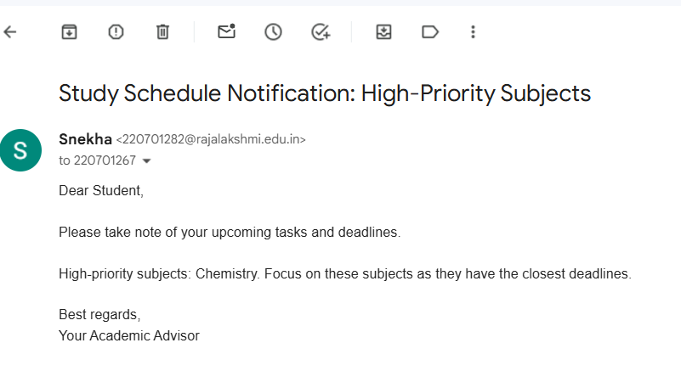

Fig 5.1 Email output for high priority subjects

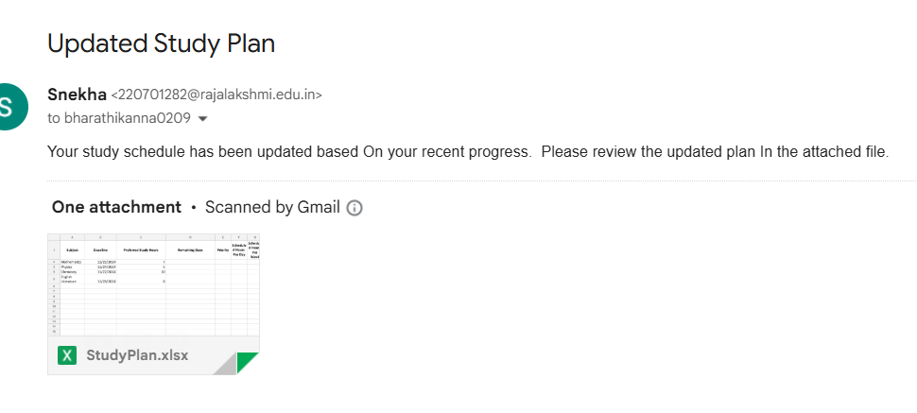

Fig 5.2 Email output for updated study plan

**APPENDIX 2: EXCEL OUTPUT SCREENSHOT**

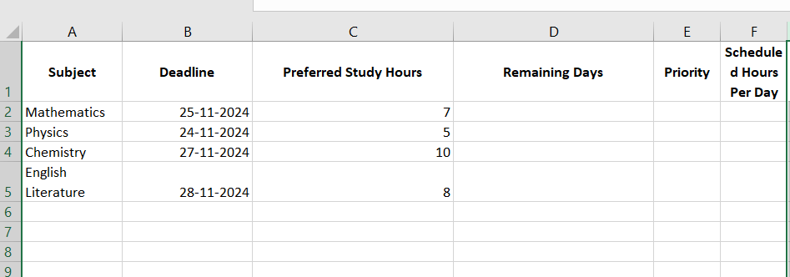

Fig 5.3 excel input

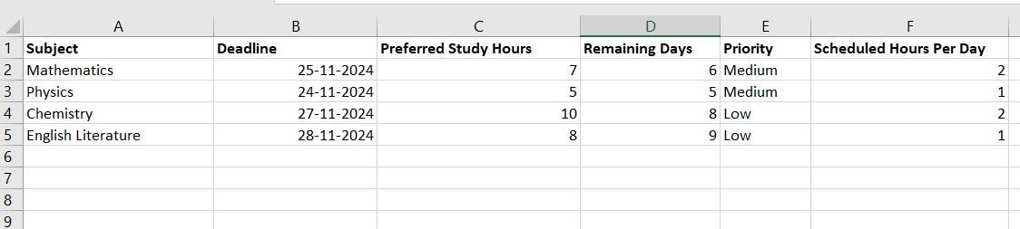

Fig 5.4 excel output for study plan

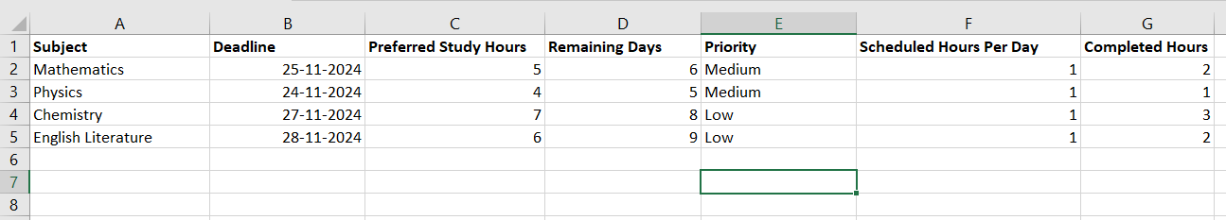

Fig 5.5 excel output for updated study plan based on completed hours

**APPENDIX 3: UIPATH WORKFLOW SCREENSHOT**

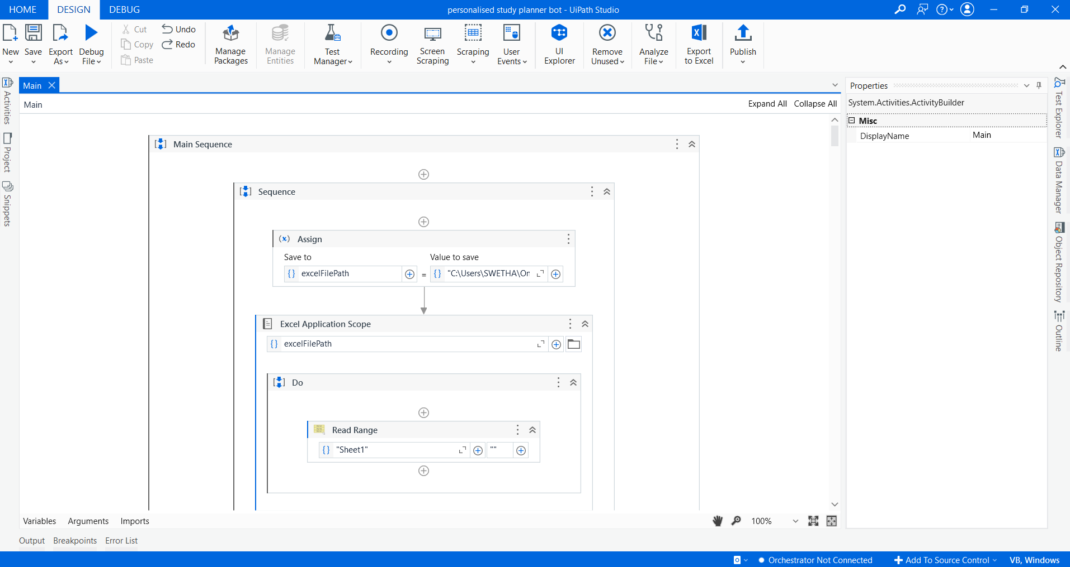

Fig 5.6 workflow screenshot 1

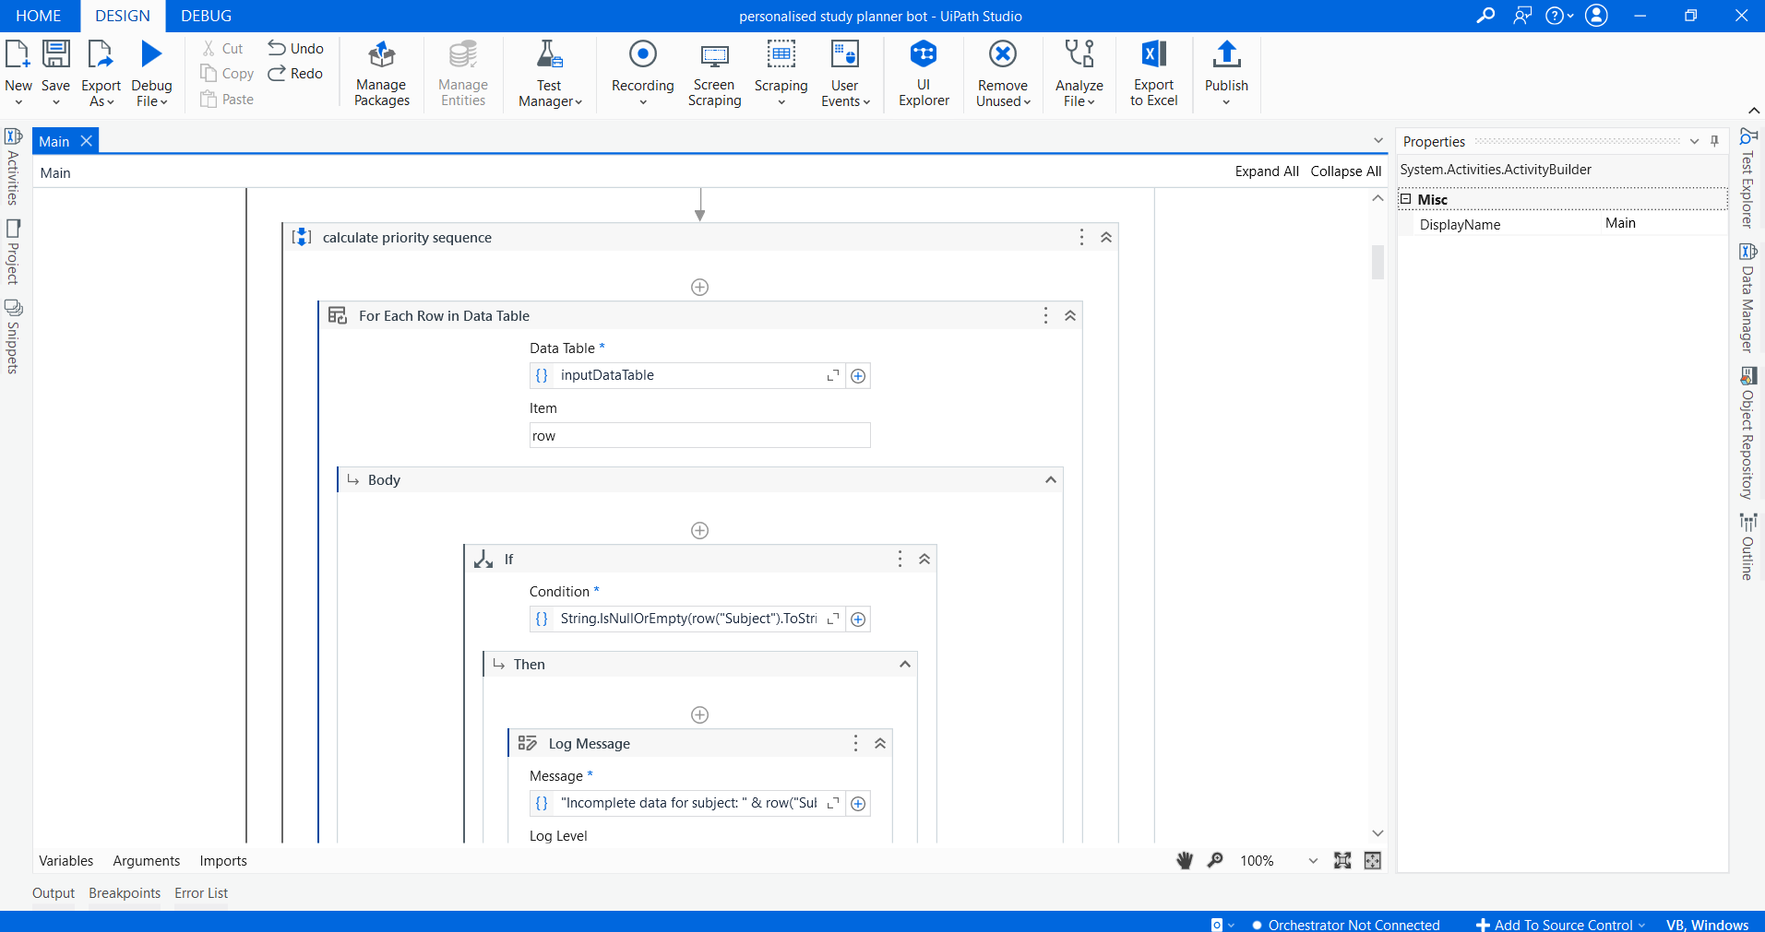

Fig 5.7 workflow screenshot 2

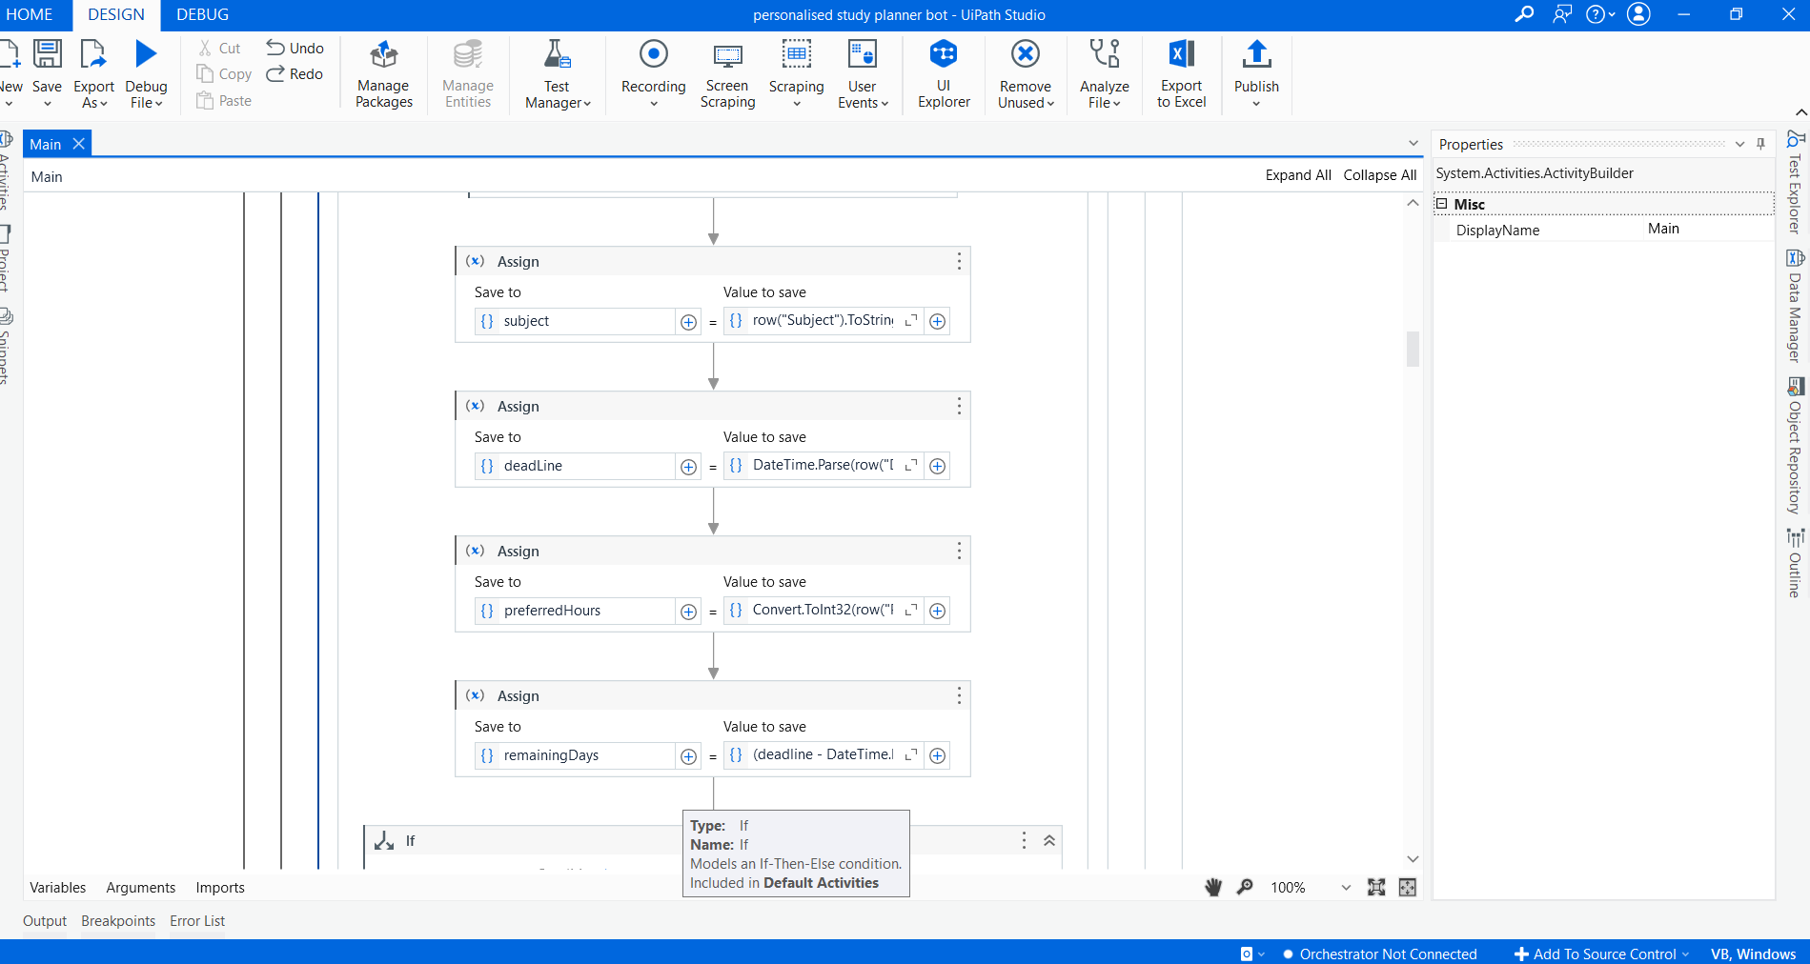

Fig 5.8 workflow screenshot 3

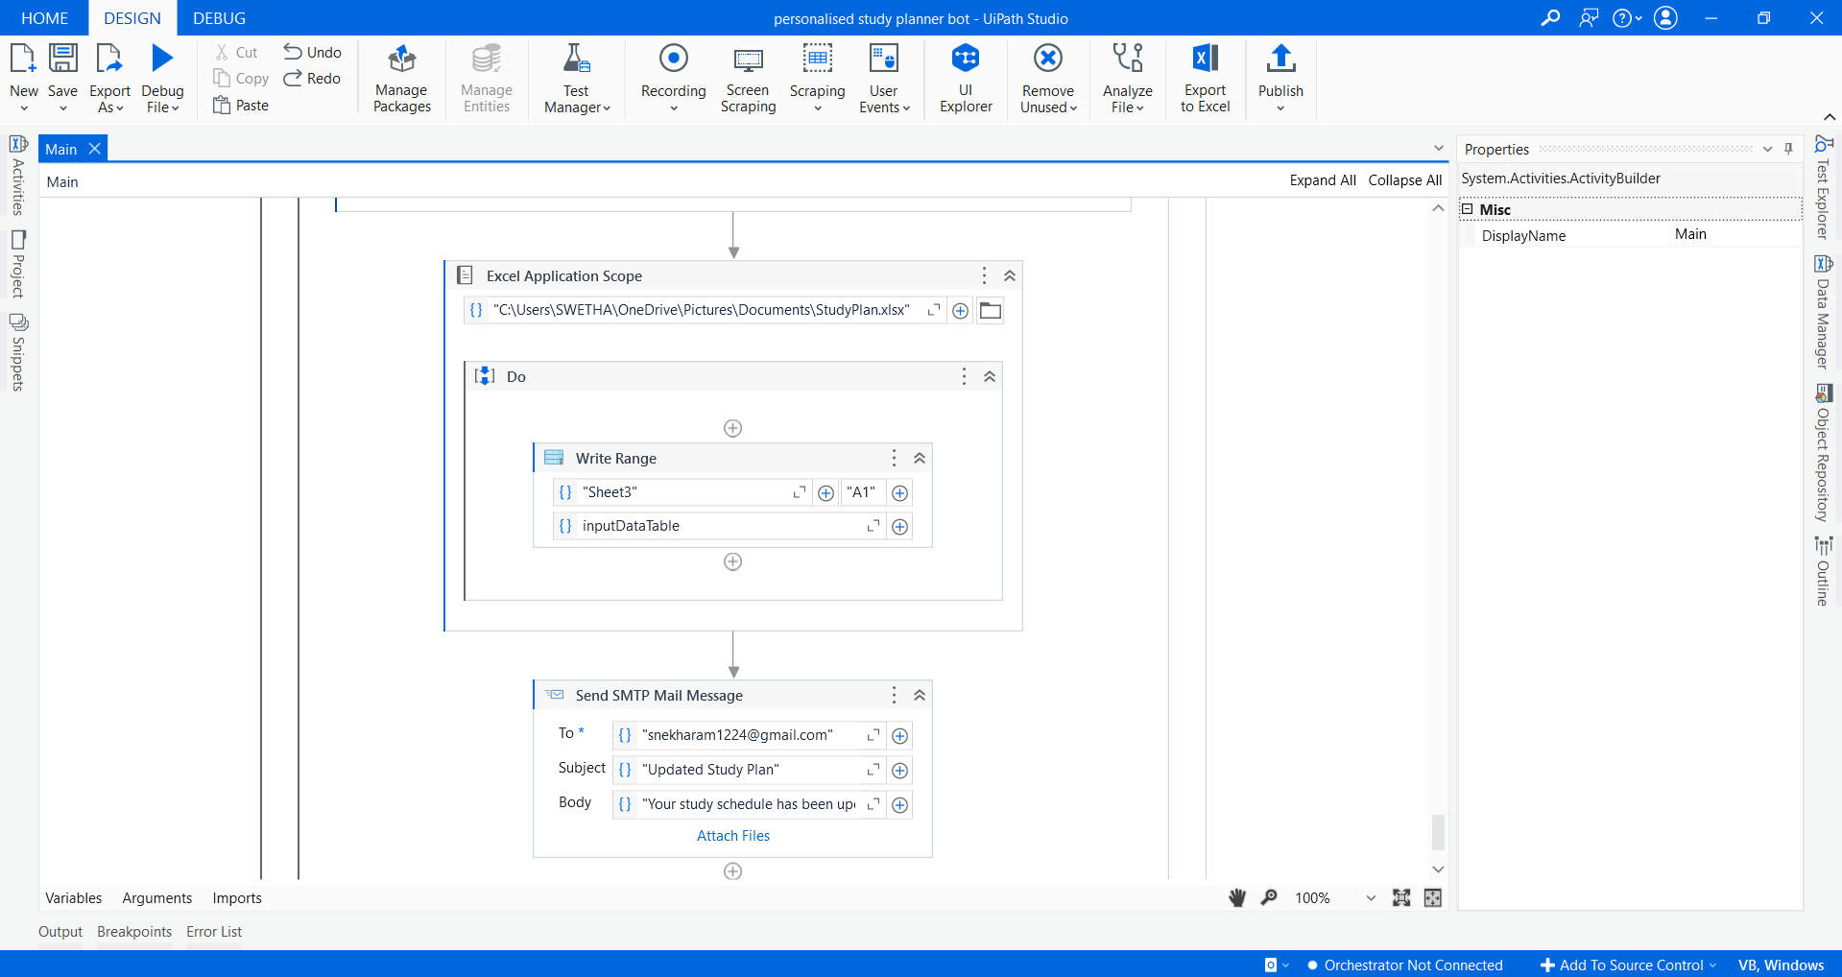

Fig 5.9 workflow screenshot 4